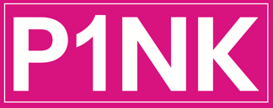
Privacy Statement
This privacy policy sets out how P1NK our businesses uses and protects information you give when you use this website. P1NK is committed to protect your privacy and we do not share emails with other parties. We may ask you to provide certain information and we will use this in accordance with privacy regulations. If you register to attend Supercar events and drive outs, you will get information related to your membership subscription.

P1NK “Use of information”
We may collect:
- name and job title
- contact information including email address
- demographic information such as postcode, preferences and interests
- other information for offers, drives, promotional days.
This is to provide the best service possible and offer our customers the best experience.
On occasions we launch new products and periodically send promotional emails about new products, special offers or other information
On occasion your information to contact you for market research purposes or events. We may contact you online, email or phone. We may use the information to customise the website according to your interests.
P1NK is committed to ensuring that your information is secure. In order to prevent unauthorised access or disclosure, we have put in place suitable physical, electronic and managerial procedures to safeguard and secure the information we collect online.

